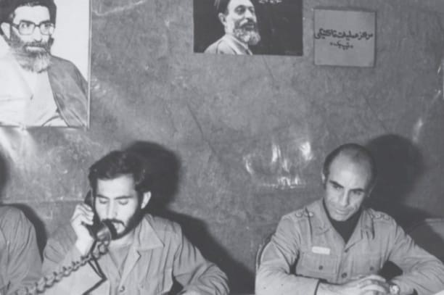States, institutions and societies in Iran, Afghanistan, Central Asia and Pakistan since the 1970s
États, institutions et sociétés en Iran, Afghanistan, Asie centrale et au Pakistan depuis les années 1970

GRADUATECONFERENCE
THURSDAY 16.11.2023

Sciences Po
28 rue des Saints-Pères

Room G009

Commander Mortefa Safari (left), Khatam camp during the Iraq-Iran War, circa. 1982, Tasnim News Agency

Organised by the Centre d’histoire du XIXe siècle (CRHXIX, Sorbonne University) and the Centre de recherches internationales (CERI, Sciences-Po), the graduate conference aims to rethink relations between states and societies in Iran, Afghanistan, Pakistan, and Central Asia since the 1970s. It adopts a comparative and trans-disciplinary approach (political sociology, religious and political history, anthropology, public policy), and pays attention to transnational trajectories and circulations of political phenomena and groups, and their relationship to the state.

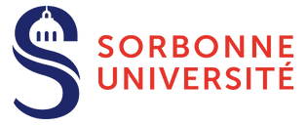
Organising Commitee
Sophia Mahroug (Sorbonne Université
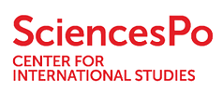
/ University of Luxembourg)
Guillaume Beaud (Sciences Po) TO REGiSTER :
bit.ly/3PX8jfa

Opening and presentation of the graduate conference | 8h30 – 9h
Session 1 : States amid emerging public policy challenges | 9h – 11h
Discussants : Sophia Mahroug (Sorbonne Université/University of Luxembourg) & Guillaume Beaud (Sciences Po)
Behnaz Khosravi (Institut national d’études démographiques): “Enfance d’une société mouvante et mouvementée : le cas de l’Iran postrévolutionnaire”
Misagh Javadpour (University of Amsterdam): “Beyond the Center: Analyzing Rasht’s Revolutionary Experience in the Iranian Revolution of 1979
– Mobilization Patterns and Violence”
Jad Tayah (Doha Institute): “Post-Conflict ‘Re-Carbonization’: The case of Afghanistan’s energy and environmental policies under the Taliban”
Jan Tomek (University of Oxford) : “Le renouveau des relations entre l’Iran et l’Eurasie centrale: un aperçu des perspectives à Téhéran, Bakou et Tachkent”
Session 2 : Political and religious thoughts in the making of the state | 11h – 13h
Discussant : Stéphane Dudoignon (École pratique des hautes études)
Salomé Michel (Université Sorbonne Nouvelle): “Pahlavi regime’s forgotten elites: the role of former leftist opponents in crafting an official State ideology in 1970s Iran”
Sophia Mahroug (Sorbonne Université/University of Luxembourg): “The making of the historiography of the Sepâh: Historians of the Islamic Revolutionary Guards Corps (1980-1989)”
Nima Behroozi (University of Melbourne): “Propaganda after neoliberalism: late cultural production in Islamic Republic of Iran”
Yasin Zare (University of Quebec in Montreal): “Examining the sociopolitical influence of Waqf following the Iranian Revolution in 1979: a case study of Astan Quds Razavi”
Lunch | 13h – 14h

Session 3 : States in the management of their territories, minorities, borders | 14h – 16h
Discussant : To be confirmed
Mélanie Sadozaï (George Washington University) : “Collision et coopération en milieu frontalier isolé : les réseaux de gouvernance informels à la frontière entre le Tadjikistan et l’Afghanistan dans le Badakhchan (1997-2021)”
Altea Pericoli (University of Oxford): “Negotiating aid access with Taliban: Muslim and secular NGOs’ humanitarian diplomacy before and after 2021”
Saeed Shafiei (Sciences Po Lyon): “L’État et les minorités ethniques en Iran: trois formes de la domination ethnique”
Muntasar Siam (Government College, Lahore): “Ethnic conflicts and strategies for integration in Pakistan: implications for policy”
Session 4 : Institutions and para-institutions in the making of state policies | 16h – 18h
Discussant : Amélie Blom (Sciences Po Lyon)
Sophie Russo (Sciences Po) : “Vernaculariser la conservation forestière : les acteurs du commerce de bois face aux politiques publiques d’afforestation au Pakistan”
Wendy Ramadan (Institut de recherche stratégique de l’École militaire) : “La fabrique du politique à travers l’émergence des think tanks en République islamique d’Iran”
Nowmay Opalinski (Université Paris 8) : “The moving lines of the state control over the Internet in Pakistan : a political geography perspective”
Guillaume Beaud (Sciences Po): “Is bureaucratic autonomy connected to civil servants’ family and professional connections within the state: the case of Pakistan’s prefectural and foreign services”
Eva Zahiri (École Pratique des Hautes Études, Sciences Po) : “Gouvernement clérical et systématisation du droit public islamique en Iran”
Conclusions | 18h – 18h15
Refreshments and drinks | 18h15
Dinner | 19h30

