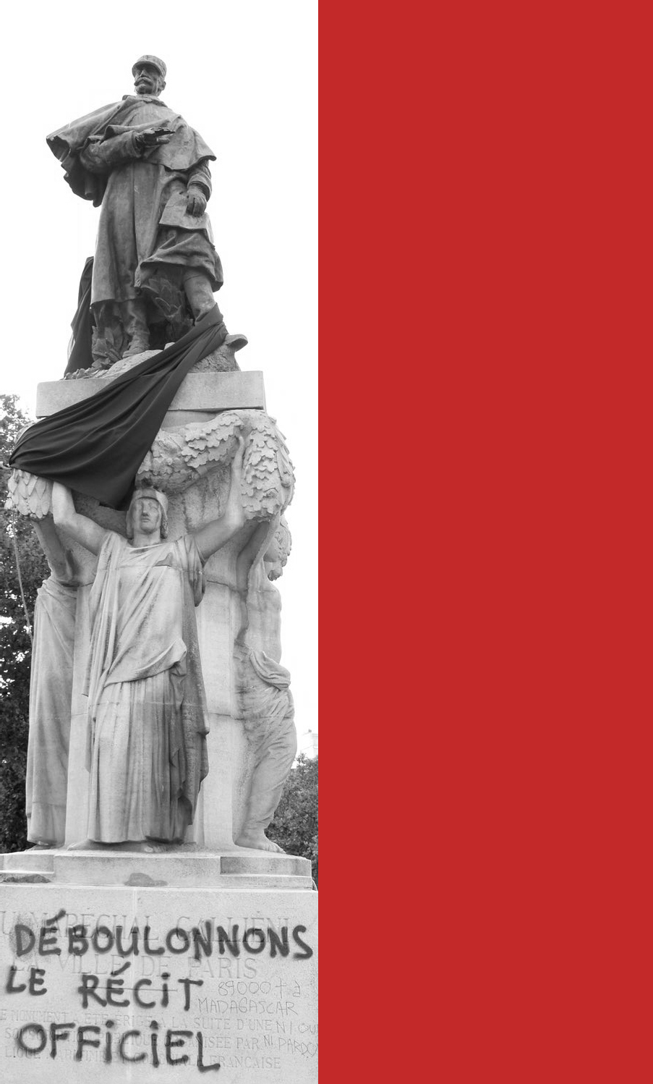
Workshop
TopplIng
STaTUES
public Spaces, Colonial Heritage, and European Identities

22-23 février 2022 Salle des actes
Université paris 1 panthéon-Sorbonne
17, rue de la Sorbonne 75005 paRIS

L’inscription se fera à l’adresse suivante :
sophie.lhermitte@univ-paris1.fr

February 22, 2022
Session 1- 14h00 -16h00

Monuments and Colonial Heritage across Europe
(This session is public)
>> What « Must Fall » ? Monuments vs historical memory
Hephzibah Israel (University of Edinburgh)
Settler monuments and memory cultures
Janne Lahti (University of Helsinki)

>> Belgian colonization in the public space : from Congo pioneers to missionaries
Idesbald Goddeeris (KU Leuven)

>> Colonialism, memory and monuments in Italy : the statue of Indro Montanelli in Milan
Karin Pallaver (University of Bologna)
>> An early decolonization ? Statues of Libertadores in Madrid
José M. Faraldo (Universidad Complutense, Madrid)

>> « Black Lives Matter » in France : contested statues and colonial controversies
Bertrand Tillier (Université Paris 1 Panthéon-Sorbonne)

Session 2 - 16h30 - 18h00

Course planning for « Monuments, Europe, and Colonialism »
(This session is a closed workshop)

February 23, 2022
Session 3 - 9h30 - 12h00

Planning the project conference in Helsinki
(This session is a closed workshop)

