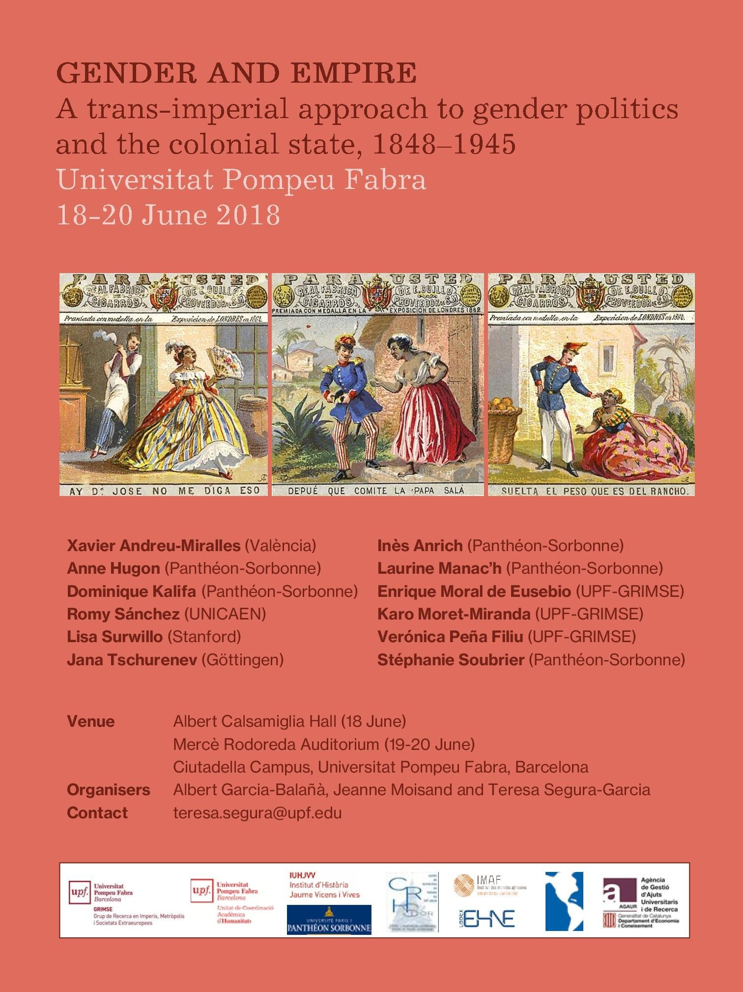

Monday 18 June

Venue: Albert Calsamiglia Hall, Roger de Llúria Building 13:30 Welcome lunch
14:30 Welcome address, Josep M. Delgado (Head of Department of Humanities, UPF) 14:35 Introduction, Albert Garcia-Balañà, Jeanne Moisand and Teresa Segura-Garcia

14:45 First panel: Emancipatory politics in colonial Cuba
Chair: Evelyn Hu-DeHart (Brown University)

“Interracial marriage and politics of intimacy in colonial Cuba, mid-nineteenth century”,
Jeanne Moisand (Paris 1 Panthéon-Sorbonne/GRIMSE)

“Caring for the cause abroad: Gender politics within Cuban separatist exiles, 1848– 1878”, Romy Sánchez (Université de Caen Normandie)

“Emancipating the Republic”, Lisa Surwillo (Stanford University)

Tuesday 19 June

Venue: Mercè Rodoreda Auditorium, Mercè Rodoreda Building 09:00 Coffee and pastries

09:30 Second panel: New voices on gender and empire (PhD students)
Chair: Stephen Jacobson (Director of Jaume Vicens Vives University Institute of History, IUHJVV, UPF)

“Colonising taste and desire: Eating and sexual practices in the Mariana Islands at the beginning of the Spanish colonial period”, Verónica Peña Filiu and Enrique Moral de Eusebio (UPF/GRIMSE)

“Religious vocation as a way to challenge familial gendered power relations”, Inès
Anrich (Paris 1 Panthéon-Sorbonne)

“Why did Shangó lose its breasts when arrived in the Caribbean? Hermeneutics of the Afro-Caribbean, between the Bildung and its early accommodations”, Karo Moret- Miranda (UFF/GRIMSE)

“Women in business: An insight into a recent dialogue between women and gender history and business history”, Laurine Manac’h (Paris 1 Panthéon-Sorbonne)

“Manly or effeminate? Gendered representations of colonial soldiers within the
French empire, 1857–1918”, Stéphanie Soubrier (Paris 1 Panthéon-Sorbonne) 13:30 Lunch

14:45 Third panel: Race and gender from discourse to practice
Chair: Clyde Plumauzille (Labex EHNE)

“Discussing the moral flaws of an “Oriental” land: Gender, nation and empire in Spain,
c. 1800–1850”, Xavier Andreu-Miralles (València)

“Gender, caste, and colonialism: The politics of ‘female education’ in western India, 1848–1890s”, Jana Tschurenev (Center for Modern Indian Studies, University of Göttingen)

“Colonised women’s agency and the Maternal and Child Welfare policy: A history of colonialism through a history of maternity (Gold Coast, Ghana, 1915–1950s)”, Anne Hugon (Paris 1 Panthéon-Sorbonne)

20:00 Workshop dinner

Wednesday 20 June

Venue: Mercè Rodoreda Auditorium, Mercè Rodoreda Building 09:00 Coffee and pastries

09:30 Fourth panel: European masculinities in colonial spaces
Chair: Linda Jones (UPF/ECERM-NEXUS)

“Gender and penal colonies: The case of the French military system”, Dominique
Kalifa (Paris 1 Panthéon-Sorbonne)

“Gender, intimacy, and colonialism in the Indian court: British tutors and royal pupils in princely India, c. 1870–1900”, Teresa Segura-Garcia (UPF/GRIMSE)

“Spanish soldiers and Afro-Cuban women: Race, gender, and nation in the metropolitan experience of the colonial war (Cuba, 1895–1898)”, Albert Garcia-Balañà (UPF/GRIMSE)

12:00 Closing remarks and debate 12:30 Lunch

